**QUIZ-2**

1. **Probability (joint/disjoint, dependent/independent):**
   1. Let E1 and E2 be events on the same sample space. If P(E1) = 0.5, and P(E2) = 0.7, can these two events be disjoint?
      1. No, these events are not disjoint.

We know the following formula:

P(A **U** B) = P(A) + P(B) - P( A ꓵ B)

If both these events are disjoint, P( E1 ꓵ E2) =0.

Therefore, P(E1 **U** E2) = P(E1) + P(E2) = 0.5+0.7 = **1.2**

Since probability cannot be more than 1, Therefore 1.2 isn't valid which means that P( E1 ꓵ E2) is not equal to 0. Thus, it proves that both these events are not disjoint.

* 1. Events E1 and E2 are independent; P(E1) = 0.3 and P(E2) = 0.5. Find P(E1 and E2), P(E1 or E2), P(E1 not E2).

SInce both events are independent,

* + 1. **P(E1 and E2)**: P(E1) * P(E2) = 0.3 * 0.5 = **0.15.**
    2. **P(E1 or E2):** P(E1) + P(E2) - P(E1 and E2) = 0.3 + 0.5 - 0.15 = **0.65.**
    3. **P(E1 not E2):** P(E1) - P(E1 and E2) = 0.3 - 0.15 = **0.15.**

1. **Bayes Theorem:**
   1. You are thinking of buying a product P. On Amazon, there are 10000 reviews for this product. You can’t read all of them, so you decided to choose a small subset of reviews to read. You know that 92% of reviews are legitimate and 8% are fake. To pick the reviews that you will read, you run your machine learning algorithm that can identify legitimate reviews with high probability: If a review is legitimate, there is 90% probability that your machine learning algorithm marks it as legitimate, and if a review is fake, there is 7% probability that your algorithm marks it as legitimate.What is the probability that the interview is legitimate when your algorithm identified it as legitimate?
      1. Let P(L) be the probability that reviews are legitimate. P(L) = 0.92.

Let P(F) be the probability that reviews are fake. P(F) = 0.08

Now,

Let P(T | L) be the probability that ML algo marked it as legitimate given that the review is legitimate. P(T | L) = 0.90.

Let P( T | F) be the probability that ML algo marked it as legitimate given that the review is Fake.. P(T | F) = 0.07

**To find:**

P(L | T) which is the probability that a review is legitimate given that ML algorithm marks it as legitimate.

**Soln:**

Using Bayes Theorem, we know that  **P(L | T) = P(T | L) * P(L) / P(T), where** we defined everything above except P(T) which is the probability that ML algorithm marks a reviews as legitimate.

Therefore,

P(L | T) = [ P(L) * P(T ∣ L) ] / [ P(L) * P(T ∣ L) + P( F ) * P( T ∣ F ) ]

P(L | T) = [ 0.92 * 0.90 ] / [ 0.92 * 0.90 + 0.08 * 0.07 ]

P(L | T) = [ 0.828 ] / [ 0.828+0.0056 ]

P(L | T) = [ 0.828 ] / [ 0.8336 ]

P(L | T) = **0.9923 or 99.3 %**

1. **Markov chains:**
   1. Consider the Markov chain that is represented with the following matrix that gives the probabilities of transitioning between the states S1, S2, S3.Draw the state transition diagram for this matrix

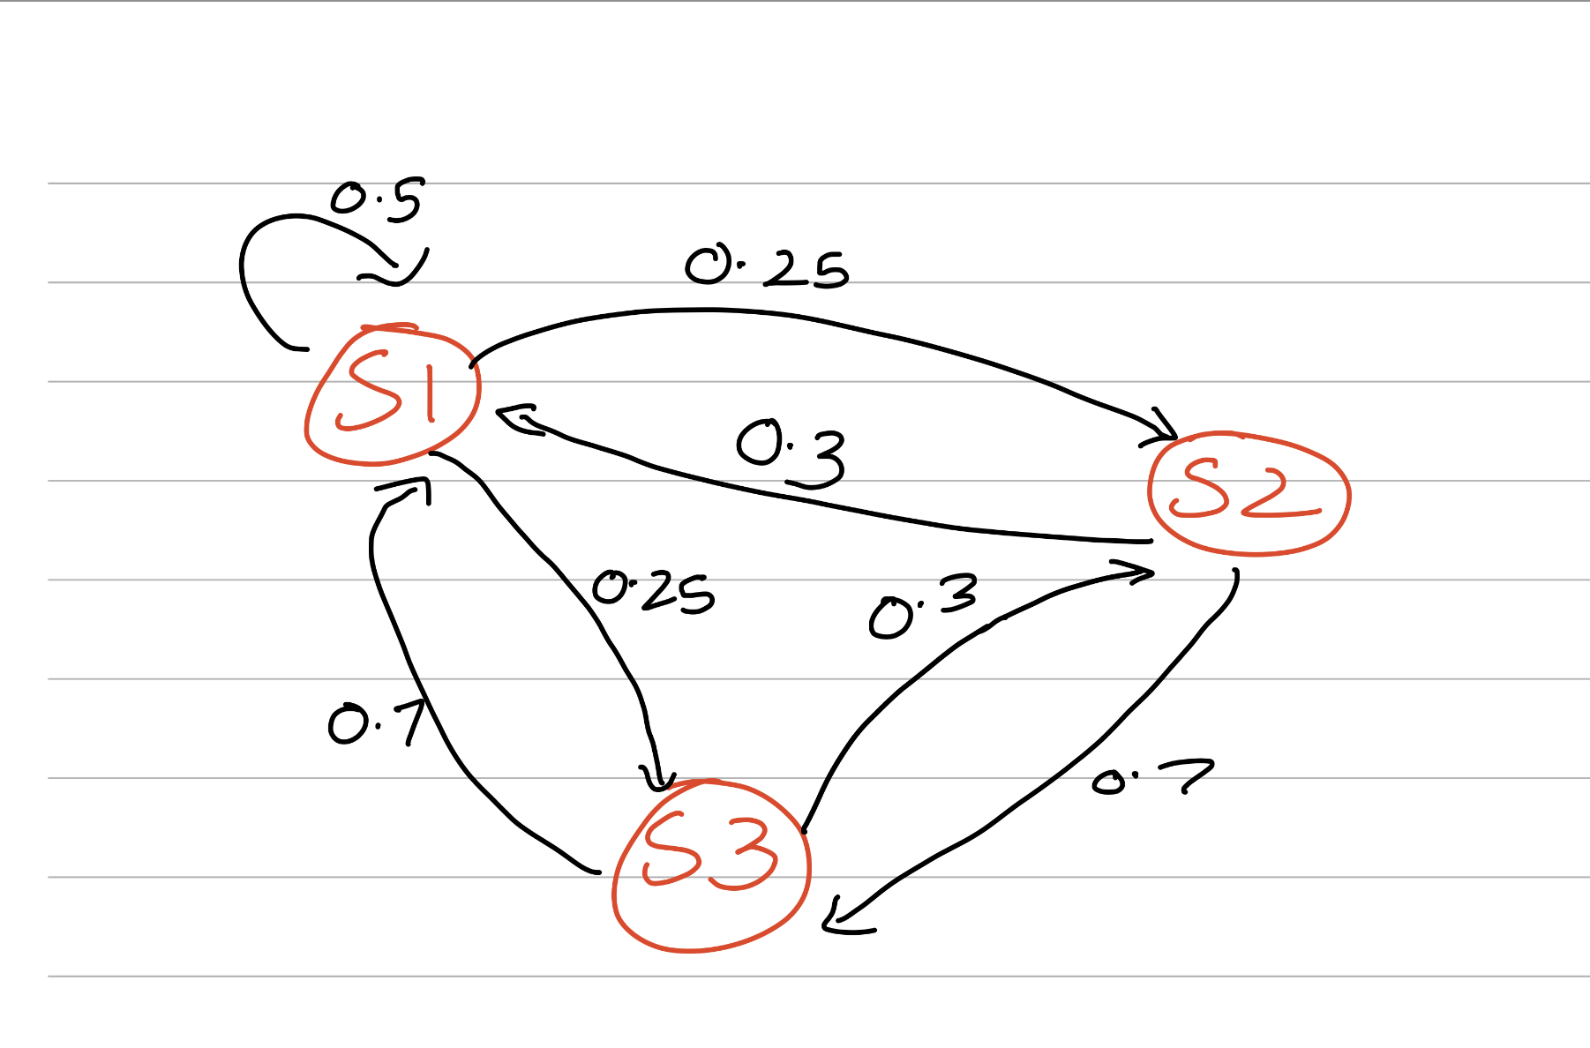

* 1. Consider the Markov chain with two states that has the following state transition diagram:The probability that a process begins at state A and will be at state B after two transitions is 48%. Find the probability x of transitioning from state A to state B.

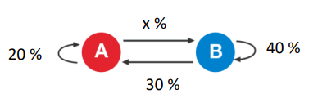

To find the probability x of transitioning from state A to state B, we first need to create a Transition Matrix T.

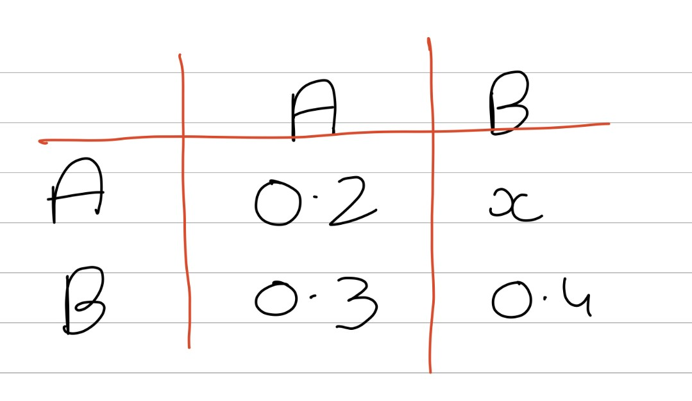

After 2 transitions , T would be: T * T = T^ 2.

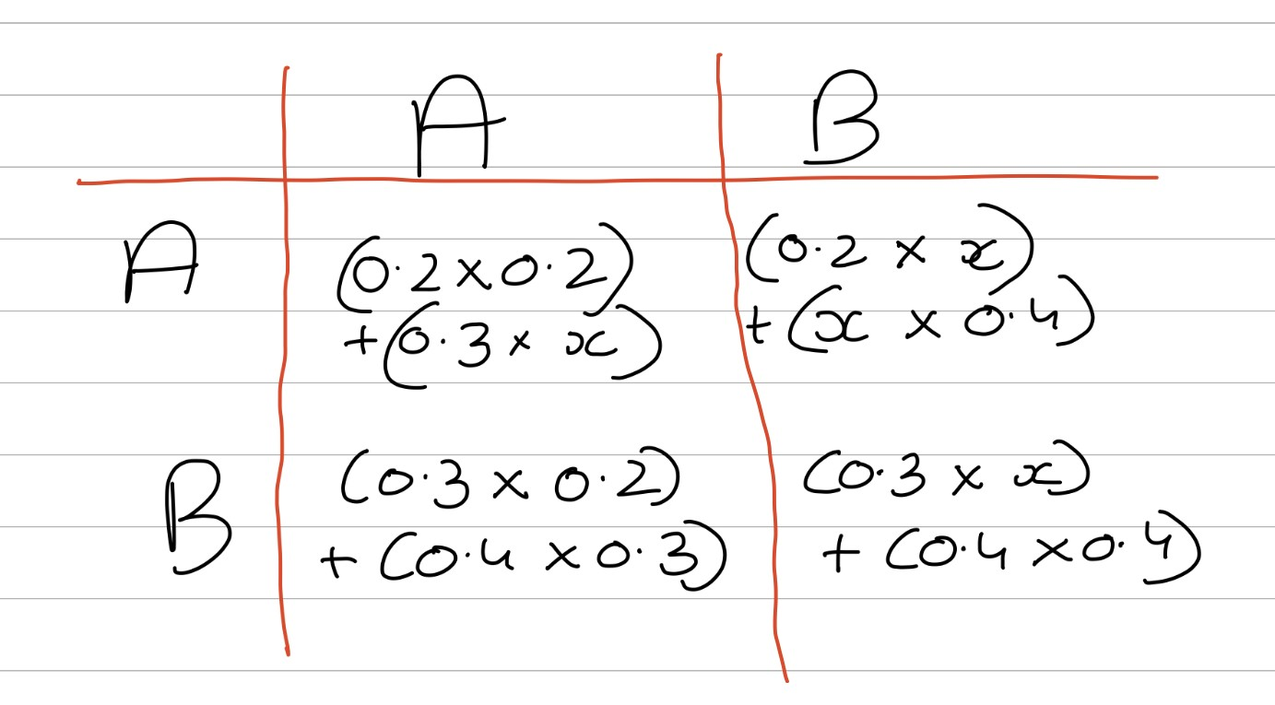

Which is,

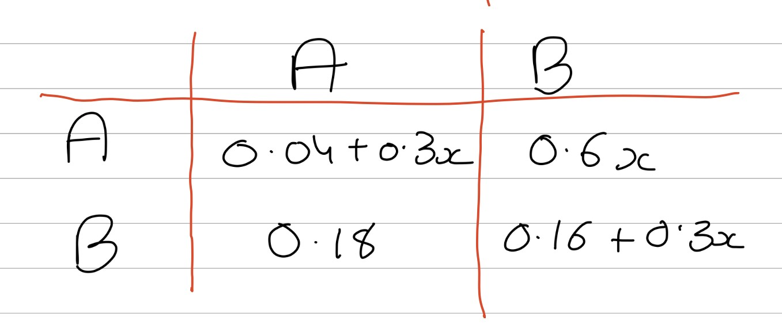

Now,

We know that The probability that a process begins at state A and will be at state B after two transitions is 48%.

Therefore,

0.6x = 0.48 (48%)

Therefore x = 0.48/0.6

**x = 0.8 or 80%**